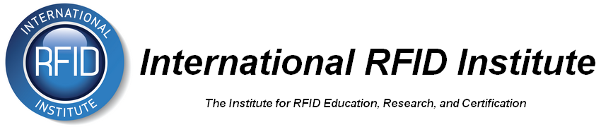

Board Meeting
June 27, 2014| 4:00 pm Eastern | Mark Roberti, Chairman

Agenda

Meeting Logistics
Meeting Location | Go To Meeting
Dial in number & PIN | Austria: +43 (0) 7 2088 1033  United States: +1 (213) 493-0619  Access Code: 919-442-426
Web connection | https://www2.gotomeeting.com/join/919442426

Invitees
Invitee | Notes
Board of directors

Agenda
Item | Who | Duration
Introductory remarks | Chair | 3 mins
Approval of minutes from previous board meeting | Secretary | 5 mins
Update on Certification subcommittee | Joe | 15 mins
Update on Exam Delivery subcommittee | Sanjiv | 15 mins
Update on Marketing & Sponsorship subcommittee | Mike | 5 mins
Update on Membership subcommittee – | Mark R | 5 mins
Confirmation that electronic vote for proposed amendments to Institute Bylaws has been sent out | Ian | 10 mins
Adjournment | Secretary | 2 mins

